CENTRALIZED GP REFERRAL MANAGEMENT SYSTEM – CRMS
DOCUMENT CONTROL & VERSION HISTORY
Document Control
Document Property | Value
Project Name | Centralized GP Referral Management - CRMS
Document Type | Business Analysis Artifact
Author | Hoang Nguyen Duy Anh (Business Analyst)
Reviewer | Peter Parker (Head of Business Analysis)
Status | Final Draft for Deployment

Version History
Version | Date | Author | Description of Changes
1.0 | 2026-6-01 | Hoang Nguyen Duy Anh | Initial Draft: Problem Statement, Planning.
2.0 | 2026-6-01 | Hoang Nguyen Duy Anh | Added Requirement Analysis, Pilot Implementation Plan, and Test Cases.
2.1 | 2026-7-09 | Hoang Nguyen Duy Anh | Final Review: Added Requirement Traceability Matrix, and finalized the document.

Table of Contents
1. Problem Statement 1
2. Planning 1
2.1. Planning Business Analysis Approach (predictive/adaptive) 1
2.2. Planning Stakeholder Engagement 1
RACI Matrix 1
Stakeholder Engagement Log: Challenges, needs and improvements 2
3. Requirements Analysis 2
3.1. Business Requirement Documentation 2
Business Objectives 2
Business Rules 3
Functional Requirements 3
Non-functional Requirements 4
Transition Requirements 4
3.2. Process Modelling 5
As-is Process 5
To-be Process 5
3.3. Gap Analysis 6
3.4. User Stories 6
3.5. Acceptance Criteria 7
4. Requirements Traceability Matrix 10
5. Solution Implementation and Evaluation 16
5.1. Implementation Strategy: Pilot 16
5.2. Test Case 16
5.3. Measure Solution Performance 17

1. Problem Statement
Australia has a mature and generally efficient health system that has a strong focus on improving its own performance. Improved information technology is one area that presents the opportunity for a more efficient hospital, at lower cost and providing better patient outcomes. The client, a large hospital network (4 large hospitals, 16,000 staff and approx 1000 beds) briefed Business Analysis (BAPL) to design and implement a system to significantly improve the management of patient referrals from GPs into the hospital system.

Previously GP referrals had targeted individual specialties within each hospital which was inefficient. The same speciality existed in multiple hospitals and would receive a duplicate referral, which artificially inflated the wait list. Some hospitals had a very long waiting list for particular specialties while other hospitals had the capacity to treat immediately but were not receiving the paper based referral. Consolidating GP referrals to a single point was expected to reduce patient waiting times through more efficient allocation of clinical, specialist and administrative resources.

2. Planning

2.1. Planning Business Analysis Approach (predictive/adaptive)
A Hybrid Delivery Framework was selected as the optimal governance and execution strategy for the CRMS initiative, effectively balancing regulatory compliance with deployment agility.
Given the enterprise scale and the critical nature of patient data processing, the project cannot tolerate architectural ambiguity. Consequently, the Requirements Inception and System Architecture phases were executed under a structured Waterfall discipline. This approach was mandatory to establish a frozen baseline for cross-hospital data models, strict regulatory compliance, and system interoperability standards (HL7/FHIR). Securing sign-off on the Business Requirements Document (BRD) at this stage mitigated systemic risks regarding clinical workflows and patient scheduling safety.
Conversely, the Solution Implementation phase transitioned into an Agile/Scrum model to accelerate time-to-value and manage delivery friction. Core system components—specifically the GP Intake Portal, the Automated Allocation Engine, and the Clinical Queue Dashboard—were decomposed into a prioritized Product Backlog and executed in 2-week Sprints. This iterative approach facilitated continuous feedback loops with clinical stakeholders, allowed for rapid UI/UX pivot based on live user testing, and ensured that the final deployment seamlessly aligned with the daily operational realities of the hospital staff.

2.2. Planning Stakeholder Engagement

RACI Matrix
Task / Deliverable | General Practitioner (GP) | Patient | Hospital Specialty Coordinator | System Administrator
Registration | R | -- | -- | A
Create and submit referral | R/A | C | I | --
Assess medical priority | I | I | R/A | --
Permit appointment | I | I | R/A | --
System maintenance | -- | -- | -- | R/A

Stakeholder Engagement Log: Challenges, needs and improvements
Stakeholders | Key Challenges (Pain points) | Suggest for improvement
General Practitioner (GP) | "I don't know the situation of specialty hospitals to address the best referral for the patient."  "I have to manually write and send paper-based referrals, which takes a lot of time and effort."  "I can't check if my referrals are submitted." | "Implement a centralized system that provides real-time visibility into specialty hospitals' waiting lists and available appointment slots. Integrate an automated electronic referral (e-referral) system to replace manual paper-based processes, featuring instant submission tracking and status notifications."
Patient | "I have to wait for so long for a special examination and treatment."  "I cannot know for certain when I can meet the specialist doctor." | "Develop an automated scheduling and queuing optimization module to significantly reduce wait times for specialist examinations. Provide patients with a transparent booking portal or SMS/email notifications that offer real-time updates and clear certainty regarding their exact appointment dates and times."
Hospital Specialty Coordinator | "It takes time to handle error referrals."  "Managing waiting lists manually often leads to errors, duplicate bookings, or missed appointments." | "Deploy an intelligent, digitized waiting list management system that allows coordinators to easily update and organize hospital-specific slots. Include an automated sorting or triaging tool based on medical priority to reduce manual workflow bottlenecks and minimize administrative errors."

3. Requirements Analysis

3.1. Business Requirement Documentation

Business Objectives
BO ID | Business Objectives
BO 1 | Automate the referral checking and approval process based on a set of available Business Rules for at least 95% of standard cases.
BO 2 | Ensure 100% of GPs, SPs and patients can track referral status in real-time right on the CRMS system interface within 3 months of implementation.
BO 3 | Achieve a minimum 99.9% accuracy rate of linked medical record data, and ensure that 100% of record accesses/edits are encrypted and automatically saved (audit log) in accordance with medical security standards before the system acceptance date (expected Q4/2026).
BO 4 | Reduce processing time when the referral is submitted by the GP until the patient receives an e-mail/SMS message to under 48 hours.

Business Rules
Rule ID | Name | Business Rule
BR 1 | Valid referral | A referral request is only considered valid when all required information is filled out, including: Patient information, Reason for Referral, Target Specialty and Summary of clinical medical history.
BR 2 | Security and privacy | Protected Health Information (PHI) must be encrypted when stored and transmitted over the network.
BR 3 | Tracking change | All actions to view, modify, delete or export transit record data must be automatically recorded by the system (Audit Log) including: User code, Time, and Specific Action. This log cannot be deleted or modified by anyone (including Admin).
BR 4 | Control and prevent duplication of patients | When receiving information from the GP, the system must automatically control the patient (Full name, Date of birth, Gender, Insurance card number/Medical identification) with the Master Patient Index (MPI) database.  1. If the overlap is over 95% according to the matching algorithm: The system automatically links the transfer record to the existing patient ID.  2. If the overlap is from 80% to < 95%: The system generates a potential duplicate alert and switches to the state of waiting for manual verification by medical staff.  3. If match < 80%: The system automatically starts a unique character ID with the latest code on the CRMS system.

Functional Requirements
FR ID | Functional Requirement | Related to
1.1 | When the application is submitted, the system must automatically change the status to Pending Review, at the same time send real-time notifications and push the application to the queue of the hospital specialty with the most suitable receiving capacity | BO 1
1.2 | The system must automatically search for suitable available time slots at specialized facilities based on clinical priority and real-time condition data. | BO 1
2.1 | The system must allow users to track their referrals’ status using specific referral code. | BO 2
2.2 | The system must send a notification to the Specialty Coordinator as soon as the referral is arranged to ask for confirmation. | BO 2
2.3 | The system must activate and send SMS/Email instructions to the patient as soon as the profile changes to Scheduled status (including time, location, doctor) or when the appointment schedule is changed/cancelled. | BO 2
3.1 | The system must record all actions (View, Edit, Delete, Export) of the medical record into an uneditable system log file (Audit Log), including detailed information about the user ID, time stamp and content of changes. | BO 3
3.2 | The system must force GPs to completely fill out core information fields (Patient Information, Medical Summary, Target Specialty) and perform automatic checks before submitting. | BO 3
3.3 | The system must encrypt all patient health information (PHI) data when storing and transmitting. | BO 3
4.1 | The system must track document processing time. If after 2 working days the file is still in Pending Review status, the system must automatically switch to warning status and send an emergency notice (Escalation) to the System Coordinator. | BO 4

Non-functional Requirements
NFR ID | Non-functional Requirement | Related to
1.1.NF | The system must complete the scan, analyze the load and provide optimal clinic/hospital allocation suggestions within less than 5 seconds from receiving valid documents. | BO 1
2.1.NF | The interface of the system must be designed to be minimalist, ensuring that a new user can get acquainted and operate proficiently after a maximum of 2 hours of training. | BO 2
2.2.NF | The system must support a minimum of 2,000 concurrent users with an average site response latency of less than 2.0 seconds for every page load request. | BO 2
4.1.NF | The system must ensure uptime of at least 99.9% (24/7/365), except for periodic maintenance periods that have been announced in advance. Total scheduled maintenance time must not exceed 4 hours per month. | BO 4

Transition Requirements
TR ID | Transition Requirement
2.1.TR | Provide a set of instruction documents (Quick Reference Guide) and short videos (under 3 minutes) integrated right on the GP Portal home page to guide doctors on how to quickly fill out the e-referral form by machine, how to look up the waiting list and how to track the status.
2.2.TR | Implement an automated notification system (via SMS and Email) with detailed instructions sent to patients immediately upon referral creation, guiding them on how to access the patient portal to self-track and monitor their referral status in real-time.
3.1.TR | The system needs to download and standardize the entire list of current GP data from the old database or from the national health data source into the CRMS system before the go-live date.
4.1.TR | Set up a quick response technical support team that operates 24/7 in the first 4 weeks after go-live to immediately handle any errors arising when switching to the new system.
4.2.TR | The old process is still partly retained to prevent the system from failing and requiring long-term maintenance, to avoid disruption during the transit process. The old process should be totally terminated only when 100% new referrals are digitalized via the new system, the system operates stably and 100% GPs and SCs are familiar with it.

3.2. Process Modelling

As-is Process
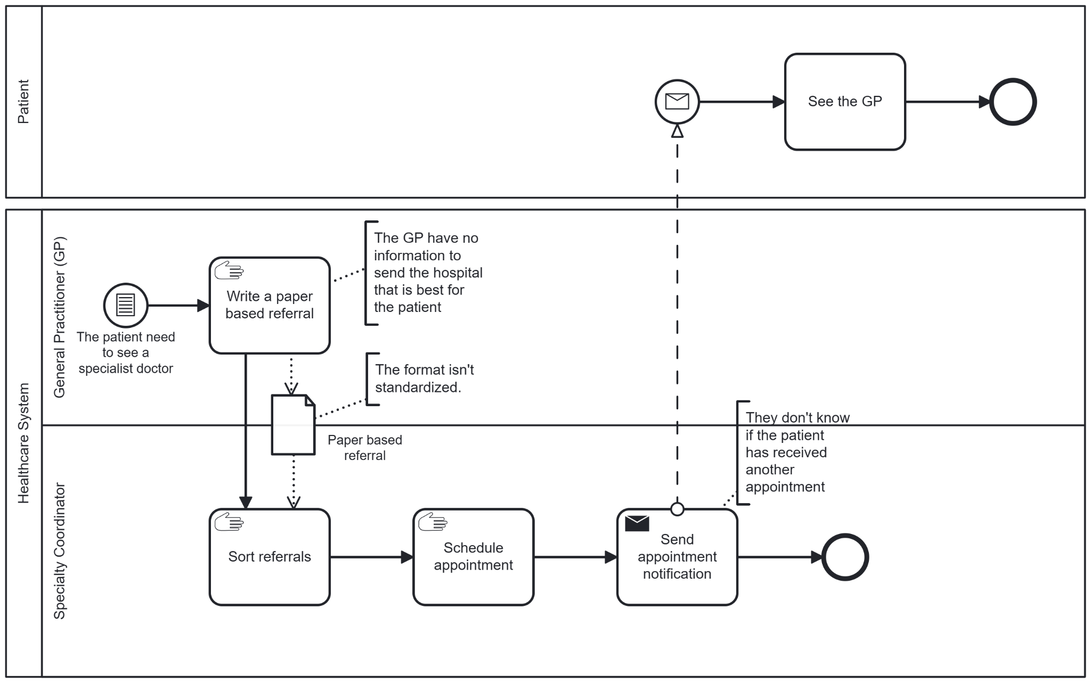

To-be Process
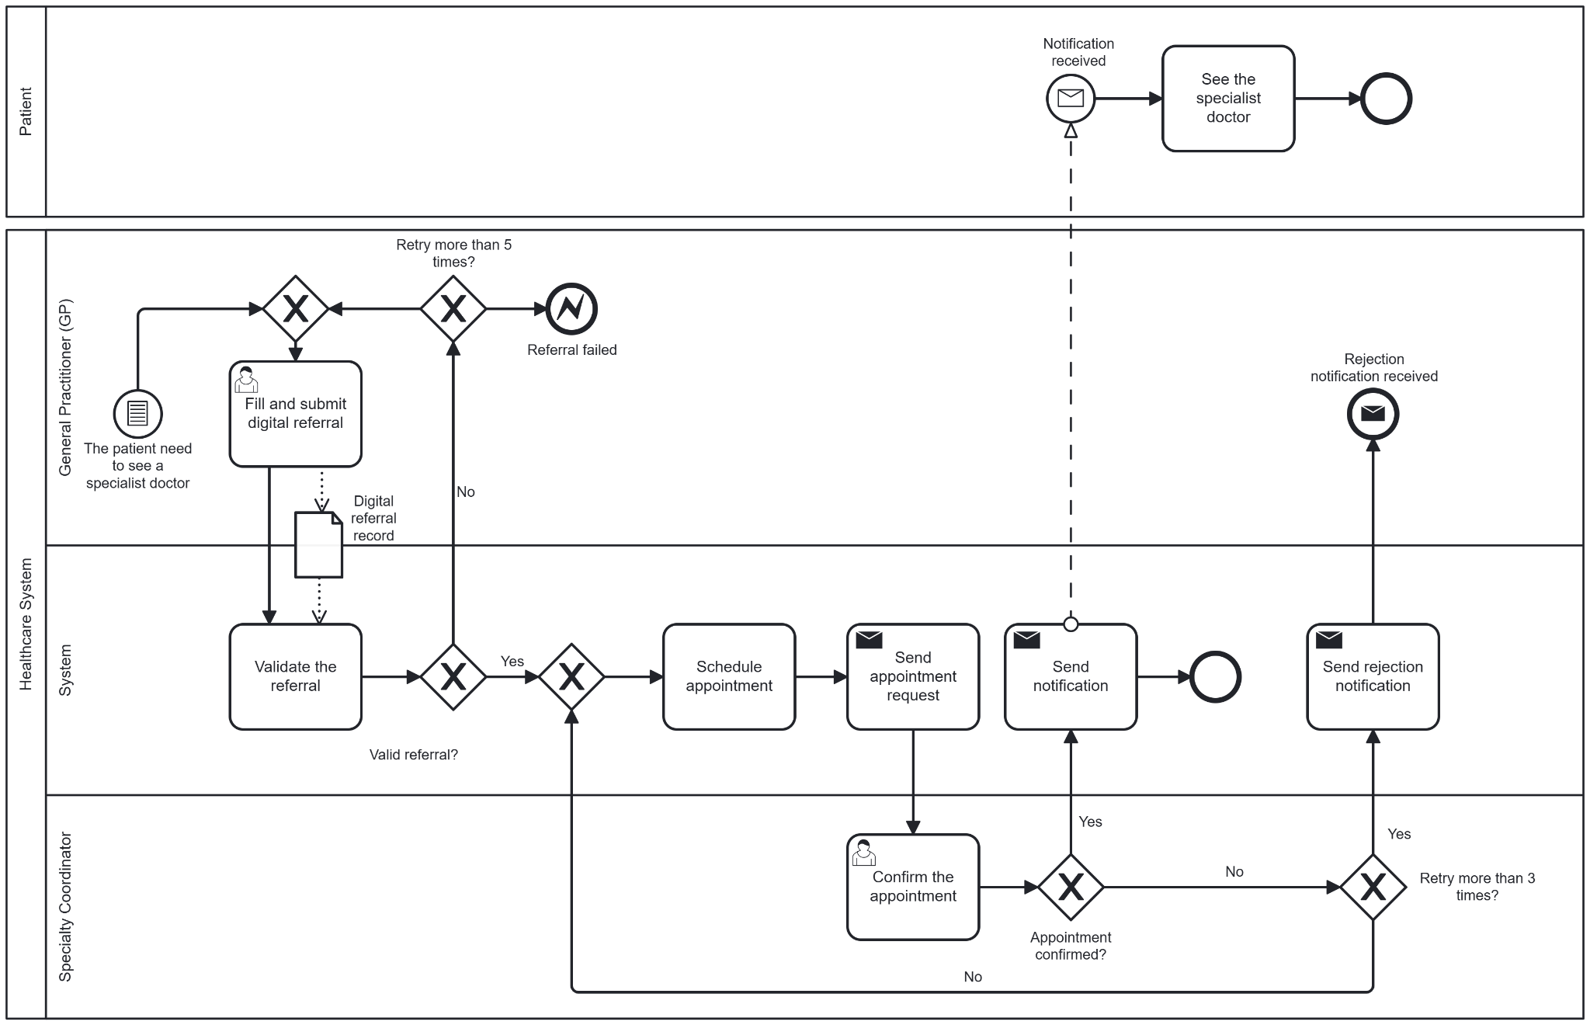

3.3. Gap Analysis
Current State | Future State | Gaps
Referrals are transmitted via legacy channels (fax, paper, email) and tracked using basic, disconnected software tools like Excel spreadsheets. | Automated systems handle routine appointment confirmations and automated retry alerts. | Heavy operational dependence on localized spreadsheets (Excel) and manual phone outreach, leading to high administrative overhead and communication bottlenecks.
Specialty Coordinators must manually log details and repeatedly call patients to confirm appointments (requiring 3+ manual retries when patients are unreachable). | Human interaction is strictly reserved for steps requiring clinical precision and final decisions (e.g., clinical triaging, specialized referral form completion, or final request approvals).
Patient data and clinical referral information are disconnected across external GP clinics and secondary care specialty databases. | External GP Electronic Medical Record (EMR) systems are seamlessly synced with the centralized CRMS via secure interfaces. | Lack of standardized integration protocols and direct software connectivity between external GP systems and the centralized secondary care database.
Booking queues and appointment slots are manually adjusted and managed by Specialty Coordinators. | The CRMS scheduling engine dynamically calculates available slots and pushes interactive self-booking links directly to patients. | Lack of automated digital touchpoints, patient portals, or self-service scheduling capabilities within the current operational model.
Tracking patient responses and managing unconfirmed slots require constant physical oversight and manual spreadsheet modifications. | The system automatically monitors response deadlines and re-allocates unconfirmed slots to other waiting patients without administrative effort.
Administrative staff and specialty coordinators are highly habituated to manual, paper-based processes. | Staff operate as advanced system supervisors, focusing their time entirely on clinical quality auditing, precision decision-making, and high-value patient interactions. | Training deficiencies regarding modern automated enterprise software platforms and data-driven clinical triaging protocols among existing administrative personnel.
Lack of familiarity with advanced workflow automation systems and digital triaging rule engines. | Full proficiency in managing CRMS exception dashboards.

3.4. User Stories
US ID | User Stories | Related to
US 1 | As a GP, I want the system to highlight missing mandatory fields in red before I hit submit, so that I can correct errors immediately without wasting time.
US 2 | As a GP, I want to save a referral as a draft, so that I can pause and look up more patient history later without losing the data I already entered.
US 3 | As a GP, I want to receive notification about my referrals' status, so that I can answer if the patient asks me.
US 4 | As a GP, I want to review my referral history, so that I can write better referrals in the future.
US 5 | As a specialty coordinator (SC), I want to receive instant notification as soon as a referral is sent to my office, so that I can handle it immediately.
US 6 | As a SC, I want to see the order of the referrals based on priority, so that I can arrange emergency cases first.
US 7 | As a SC, I want to send a request for the GP to add more information if the referral is lacking information, so that I can make better decisions.
US 8 | As a patient, I want to receive an SMS message or email as soon as the GP sends the referral, so that I know the process has started.
US 9 | As a patient, I want to be able to search for my referral's status, so that I can feel less worry.

3.5. Acceptance Criteria
AC ID | Related US ID | Given | When | Then
AC 1.1. | US 1 | The GP is on the referral creation page and has left one or more mandatory fields blank | the GP clicks the "Submit" button | the system does not submit the form, displays a global error message, and highlights all blank mandatory fields with a clear red border
AC 1.2. | US 1 | A mandatory field is highlighted in red due to missing data | the GP enters valid input into that specific field | the red highlight disappears instantly from that field
AC 1.3. | US 1 | Multiple mandatory fields are left blank upon submission | the submission fails validation | the page automatically scrolls and puts focus on the first invalid field
AC 2.1. | US 2 | The GP is filling out a new referral form with partial data | the GP clicks the "Save as Draft" button | the system saves all current inputs, displays a "Draft saved successfully" notification, and does not require mandatory fields to be complete
AC 2.2. | US 2 | The GP has modified an existing draft or a new form | the system detects 2 minutes of inactivity or if the GP attempts to navigate away without saving | a prompt appears to ask if they want to save changes, or it autosaves the data to prevent loss
AC 2.3. | US 2 | The GP has previously saved drafts | the GP navigates to the "Drafts" section in their portal | the system displays a list of all drafts with correct timestamps, and clicking a draft reloads the exact saved state
AC 3.1. | US 3 | The status of a GP’s submitted referral changes (e.g., from Pending to Allocated or Request Info) | the GP is logged into the CRMS portal | an in-app badge notification is triggered instantly in the notification center showing the new status
AC 3.2. | US 3 | A submitted referral has been accepted or scheduled by a hospital. | the status update occurs in the background | an automated email notification containing the Referral ID and current status summary is sent to the GP’s registered email address
AC 3.3. | US 3 | the GP clicks on a received status notification | the page redirects them to the referral details | the system shows a clear, dated tracking history of all status transformations
AC 4.1. | US 4 | the GP is on the main dashboard portal | they click on the "Referral History" tab | the system displays a chronological list of all referrals submitted by this GP, including Patient Name, Referral Date, Specialty, and Final Outcome
AC 4.2. | US 4 | the GP is viewing their referral history list | they apply filters by Date Range, Specialty, or Search by Patient Name | the system dynamically filters the history list to only show matching records
AC 4.3. | US 4 | the GP is browsing past records in the history list | they click on any completed or historical referral item | the system displays a read-only view of the full referral details, including clinical notes and attachments
AC 5.1. | US 5 | the allocation engine or an intake officer assigns a new referral to a specific hospital specialty office | the Specialty Coordinator for that office is logged into the system | an audible sound and a high-priority push notification pop up on their dashboard immediately
AC 5.2. | US 5 | a new referral is successfully routed to the SC’s department | the notification lands on their dashboard | the "Unprocessed/New" counter in their incoming queue increases by 1 in real-time
AC 5.3. | US 5 | the SC clicks on the incoming referral instant alert | the alert interaction occurs | the system directly opens that specific referral record in an editable assessment view for immediate processing
AC 6.1. | US 6 | the SC navigates to their department’s active referral intake queue | the list loads onto the screen | the system automatically sorts the list with high-risk/emergency categories (e.g., Category 1 - Urgent) at the top, followed by lower categories
AC 6.2. | US 6 | referrals in the queue have varying levels of clinical urgency | displayed on the dashboard list | emergency cases are distinctly marked with a prominent red visual flag or label indicating the priority score
AC 6.3. | US 6 | the default queue is sorted by priority | the SC manually clicks on the "Submission Date" column header | the system re-sorts the queue chronologically while maintaining an easy toggle to switch back to the priority view
AC 7.1. | US 7 | the SC is reviewing a referral and determines that clinical data or documents are missing | the SC clicks the "Request Information" button | a modal opens requiring the SC to select or type the specific missing criteria before proceeding
AC 7.2. | US 7 | the SC submits the information request back to the GP | the request action is processed by the server | the referral status shifts to "Information Requested", moves out of the SC's primary action queue, and is locked from further SC changes until the GP responds
AC 7.3. | US 7 | a referral is in the "Information Requested" state | the originating GP uploads the requested files/notes and clicks "Resubmit" | the status automatically changes to "Resubmitted", and it reappears at the top of the SC's active work list with a history flag
AC 8.1. | US 8 | a GP successfully submits a new referral containing valid patient contact details | the referral status becomes "Submitted" in the central engine | the referral status becomes "Submitted" in the central engine
AC 8.2. | US 8 | the patient receives the referral confirmation email | they check the message details | it must include a tracking reference number and a secure web link to check progress without exposing sensitive health information
AC 9.1. | US 9 | The patient is on the "Search Referral Status" interface | The patient enters a valid referral ID into the search bar and clicks the "Search" button | The system displays the correct current status of the referral
AC 9.2. | US 9 | The patient is on the "Search Referral Status" interface | The patient enters a referral ID that does not exist in the system and clicks "Search" | The system displays an error message: "Referral ID not found. Please check and try again."
AC 10.1. | US 10 | The system has successfully scheduled an appointment for the patient's referral | The system automatically sends a notification (via SMS or Email) to the patient's contact information | The received notification must clearly display all required fields: Appointment Time, Clinic Location, Assignee Doctor's Name, and preparation notes (if any)

4. Requirements Traceability Matrix
ID | BUSINESS REQUIREMENT | FUNCTIONAL REQUIREMENT | NON-FUNCTIONAL REQUIREMENT | TRANSITION REQUIREMENT | TEST CASE | PRIORITY | STATUS
1.1 | 1. Automate the referral checking and approval process based on a set of available Business Rules for at least 95% of standard cases. | 1.1. When the application is submitted, the system must automatically change the status to Pending Review, at the same time send real-time notifications and push the application to the queue of the hospital specialty with the most suitable receiving capacity |  |  | TC001 | Medium | Not Started
1.2 |  | 1.2. The system must automatically search for suitable available time slots at specialized facilities based on clinical priority and real-time condition data. |  |  | TC002 | High | Not Started
1.1.NF |  |  | 1.1.NF. The system must complete the scan, analyze the load and provide optimal clinic/hospital allocation suggestions within less than 5 seconds from receiving valid documents. |  | TC003 | Medium | Not Started
2.1 | 2. Ensure 100% of GPs, SPs and patients can track referral status in real-time right on the CRMS system interface within 3 months of implementation. | 2.1. The system must allow users to track their referrals’ status using specific referral code. |  |  | TC004 | High | Not Started
2.1.TR |  |  |  | 2.1.TR. Provide a set of instruction documents (Quick Reference Guide) and short videos (under 3 minutes) integrated right on the GP Portal home page to guide doctors on how to quickly fill out the e-referral form by machine, how to look up the waiting list and how to track the status. |  | Low | Not Started
2.2.TR |  |  |  | 2.2.TR. Implement an automated notification system (via SMS and Email) with detailed instructions sent to patients immediately upon referral creation, guiding them on how to access the patient portal to self-track and monitor their referral status in real-time. |  | Low | Not Started
2.2 |  | 2.2. The system must send a notification to the Specialty Coordinator as soon as the referral is arranged to ask for confirmation. |  |  | TC005 | High | Not Started
2.3 |  | 2.3. The system must activate and send SMS/Email instructions to the patient as soon as the referral changes to Scheduled status (including time, location, doctor) or when the appointment schedule is changed/cancelled. |  |  | TC006 | High | Not Started
2.1.NF |  |  | 2.1.NF. The interface of the system must be designed to be minimalist, ensuring that a new user can get acquainted and operate proficiently after a maximum of 2 hours of training. |  |  | High | Not Started
2.2.NF |  |  | 2.2.NF. The system must support a minimum of 2,000 concurrent users with an average site response latency of less than 2.0 seconds for every page load request. |  |  | High | Not Started
3.1 | 3. Achieve a minimum 99% accuracy rate of linked medical record data, and ensure that 100% of record accesses/edits are encrypted and automatically saved (audit log) in accordance with medical security standards before the system acceptance date (expected Q4/2026). | 3.1. The system must record all actions (View, Edit, Delete, Export) of the medical record into an uneditable system log file (Audit Log), including detailed information about the user ID, time stamp and content of changes. |  |  | TC007 | High | Not Started
3.2 |  | 3.2. The system must force GPs to completely fill out core information fields (Patient Information, Medical Summary, Target Specialty) and perform automatic checks before submitting. |  |  | TC008 | Medium | Not Started
3.3 |  | 3.3. The system must encrypt all patient health information (PHI) data when storing and transmitting. |  |  |  | High | Not Started
3.1.TR |  |  |  | 3.1.TR. The system needs to download and standardize the entire list of current GP data from the old database or from the national health data source into the CRMS system before the go-live date. |  | Medium | Not Started
4.1 | 4. Reduce processing time when the referral is submitted by the GP until the patient receives an e-mail/SMS message to under 48 hours. | 4.1. The system must track document processing time. If after 2 working days the file is still in Pending Review status, the system must automatically switch to warning status and send an emergency notice (Escalation) to the System Coordinator. |  |  | TC009 | Medium | Not Started
4.1.NF |  |  | 4.1.NF. The system must ensure uptime of at least 99.9% (24/7/365), except for periodic maintenance periods that have been announced in advance. Total scheduled maintenance time must not exceed 4 hours per month. |  |  | Medium | Not Started
4.1.TR |  |  |  | 4.1.TR. Set up a quick response technical support team that operates 24/7 in the first 4 weeks after go-live to immediately handle any errors arising when switching to the new system. |  | High | Not Started
4.2.TR |  |  |  | 4.2.TR. The old process is still partly retained to prevent the system from failing and requiring long-term maintenance, to avoid disruption during the transit process. The old process should be totally terminated only when 100% new referrals are digitalized via the new system, the system operates stably and 100% GPs and SCs are familiar with it. |  | Medium | Not Started

5. Solution Implementation and Evaluation

5.1. Implementation Strategy: Pilot
Objective: pilot with a few GPs and hospitals for a period of time to collect feedback, fix errors, and optimize processes before applying to the entire hospital network.
Scope:
- Duration: 1 working week (Monday to Saturday)
- Participants: 10 GPs that best represent the population, 2 senior Specialty Coordinator, and IT team.

5.2. Test Case
ID | Description | Pre-conditions | Test steps | Expected result
TC001 | Validate status change to "Pending Review" and specialty routing upon submission. | The GP clicked on 'Create New Referrals' to enter the referral form interface. | 1. Complete referral form.  2. Click 'Submit'.  3. Check status in 'My Referrals'. | Status updates to 'Pending Review'.
TC002 | Verify auto-search for suitable slots based on clinical priority. | Waitlist data have already been integrated into the system. | 1. Submit a referral.  2. Check the request sent to the Specialty Coordinator. | The system sends a request including patient and appointment information to the best available hospital specialty for confirmation.
TC003 | Verify users can track status using a specific referral code. | A referral code was generated when the GP initiated a referral. | 1. Click on 'Track My Referral'.  2. Enter valid referral code.  3. Compare the status shown on the screen with the real status of the referral. | The screen showed the status history with time that fit the real time the status was updated.
TC004 | Ensure allocation suggestions are provided within 5 seconds of scan. | System load under 50% capacity. | 1. Submit valid referral.  2. Start timer.  3. Capture response time for suggestions. | Suggestion is provided in less than or equal to 5 seconds and clinically optimal.
TC005 | Validate notifications sent to the SC when the suggestions are made. | The Specialty Coordinator account is active and configured to receive notifications. | 1. Use a GP account to initiate a valid referral.  2. Wait 5 seconds for the system to generate the appointment request.  3. Use a SC account to check the notification. | An immediate notification is delivered to the SC account requesting confirmation.  The notification contains details about the appointment.
TC006 | Validate notifications sent to the patient | Patient contact information (Email, Phone number) is valid.  A valid appointment request is sent to the SC. | 1. Log in the SC account to confirm the appointment.  2. Check the patient's mobile device and email box. | The patient immediately receives an SMS and an Email containing precise details (time, location, and attending doctor).
TC007 | Check the Audit Log to see if every change to the referral is recorded. | Several referrals are initiated and currently in different stages of their life cycle. | 1. Use GP, SC and patient accounts to collect the current status of the referral.  2. Use an Admin account to query the backend database to view the Audit Log table.  3. Compare the Audit Log with the data collected from the user's account. | Every action (View, Edit, Export) is captured.  Each log entry accurately stores the user ID, timestamp, action type and a delta of the modified data.
TC008 | Data validation when the GP fill the referral form | A GP user is logged in and navigating the "Create New Referral" form. | 1. Leave the "Patient Information" block blank, complete the rest of the form, and click Submit.  2. Complete the form but enter an invalid data format (e.g., a future Date of Birth). Click Submit.  3. Leave "Target Specialty" unselected and click Submit.  4. Populate all mandatory fields with valid data and click Submit. | For steps 1, 2, and 3: The system automatically blocks submission, performs real-time validation checks, and flags the errors with red indicators next to the missing/invalid fields.  For step 4: Validation passes cleanly, and the referral is successfully submitted.
TC009 | Handle late response | A valid referral was submitted.  A time-mocking tool (Mock Clock) is available to manipulate server time. | 1. Fast-forward the system clock past the 2-working-day threshold.  2. Verify the alert in the SC account. | An emergency escalation notice is instantly dispatched and visible in the System Coordinator's inbox.

5.3. Measure Solution Performance
KPIs and Metrics | Define | Collecting Method
Average Turnaround Time | The average time from the time the GP presses the button to send the referral file on the CRMS system until the patient receives appointment notification. | The system automatically records (timestamps) the time the profile is created and the time the notification is sent. Calculation formula: Total processing time / Total number of documents.
Percentage of referrals completed on time | Percentage of referral applications processed and completed within the specified time frame. | Retrieve data from the system database, filter out the number of records with Turnaround Time <= 48 hours and then divide by the total number of records processed in a period of time.
System Adoption Rate | Percentage of GPs and medical staff at affiliated practices that actually operate and use a CRMS system to manage referrals (instead of using traditional paperwork/email). | Extract reports from system log: Number of active accounts (Active Users) out of the total number of accounts granted in the month, or the ratio of records going through CRMS to the total number of actual referrals.
Data Error Rate | Percentage of records with data errors (such as incorrect administrative information, specialty synchronization errors, lost attachments) during the process of communication between medical levels. | Automatically collected through system error logs combined with the number of error feedback reports (Feedback/Bug reports) from Specialty Coordinator sent back to the system.
Customer Satisfaction Score | The score evaluates the satisfaction of end users (GP doctors, hospital reception staff) regarding the user experience, real-time monitoring features and convenience of the system. | Deploy survey/questionnaire periodically every quarter right on the system interface after users complete a series of tasks.

